**TOPOLOGI JARINGAN**

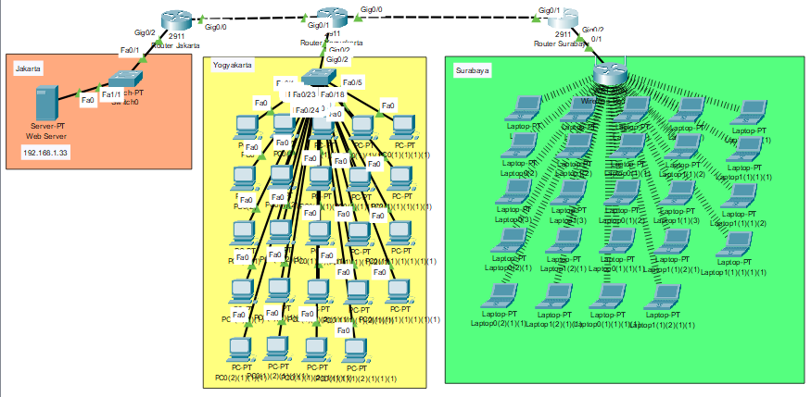

**KONFIG ROUTER JAKARTA**

|  |
| --- |
| Router>en  Router#conf t  Router(config)#int gi0/0  Router(config-if)#ip address 192.168.11.1 255.255.255.0  Router(config-if)#no shut  Router(config-if)#exit  Router(config)#int gi0/2  Router(config-if)#ip address 192.168.1.32 255.255.255.0  Router(config-if)#no shut  Router(config-if)#exit  Router(config)#ip route 192.168.2.0 255.255.255.0 192.168.11.2 |

**KONFIG ROUTER YOGYAKARTA**

|  |
| --- |
| Router>en  Router#conf t  Router(config)#int gi0/0  Router(config-if)#ip address 172.16.11.1 255.255.0.0  Router(config-if)#no shut  Router(config-if)#exit  Router(config)#int gi0/1  Router(config-if)#ip address 192.168.11.2 255.255.255.0  Router(config-if)#no shut  Router(config-if)#exit  Router(config)#int gi0/2  Router(config-if)#ip address 192.168.2.32 255.255.255.0  Router(config-if)#no shut  Router(config)#ip route 192.168.1.0 255.255.255.0 192.168.11.1  Router(config)#ip route 192.168.1.0 255.255.255.0 172.16.11.2 |

**KONFIG ROUTER SURABAYA**

|  |
| --- |
| Router>en  Router#conf t  Router(config)#int gi0/1  Router(config-if)#ip address 172.16.11.2 255.255.0.0  Router(config-if)#no shut  Router(config-if)#exit  Router(config)#int gi0/2  Router(config-if)#ip address 192.168.1.32 255.255.255.0  Router(config-if)#no shut  Router(config-if)#exit  Router(config)#ip route 192.168.2.0 255.255.255.0 172.16.11.1 |

**KONFIG WEBSERVER, DATABASE SERVER DAN DNS SERVER**

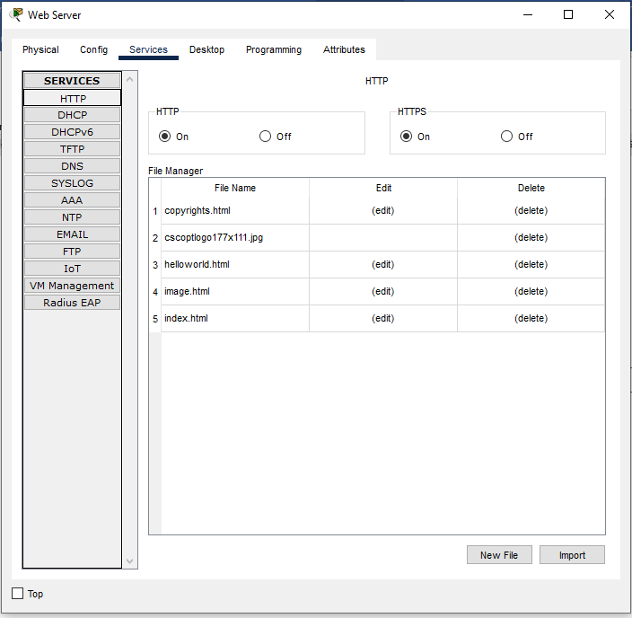

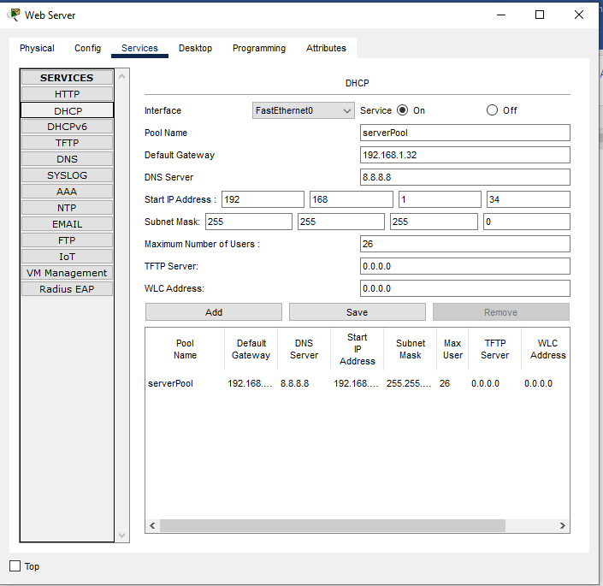

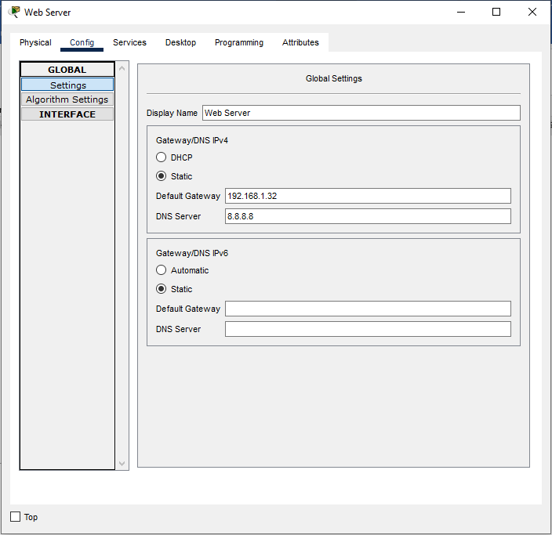

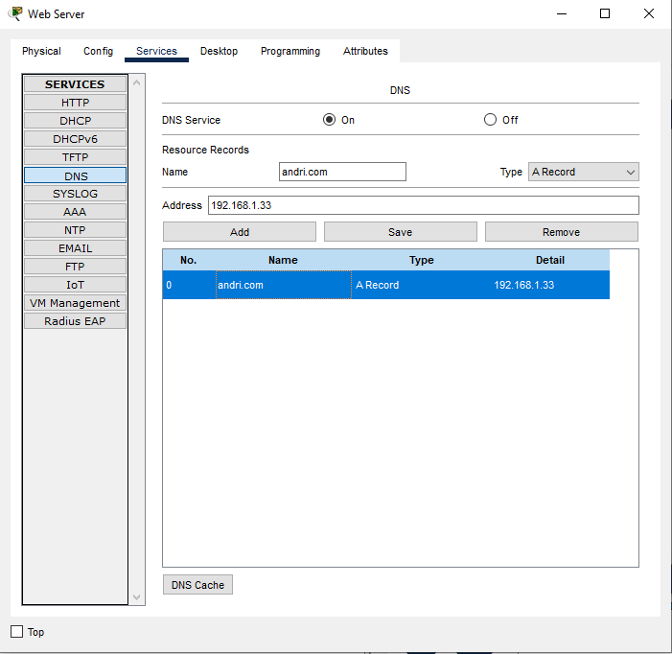

**KONFIG ACCESSPOINT**

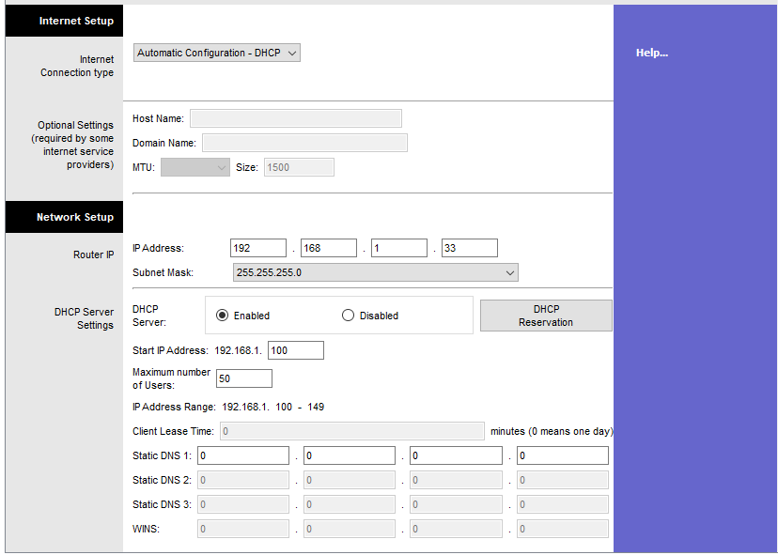

**PENGUJIAN KONFIG ROUTING OSPF**

Isi dengan Konfigurasi Routing

**PENGUJIAN AKSES SERVER DARI LAN YOGYAKARTA**

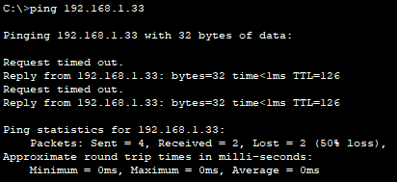

**PENGUJIAN AKSES SERVER DARI LAN SURABAYA**

